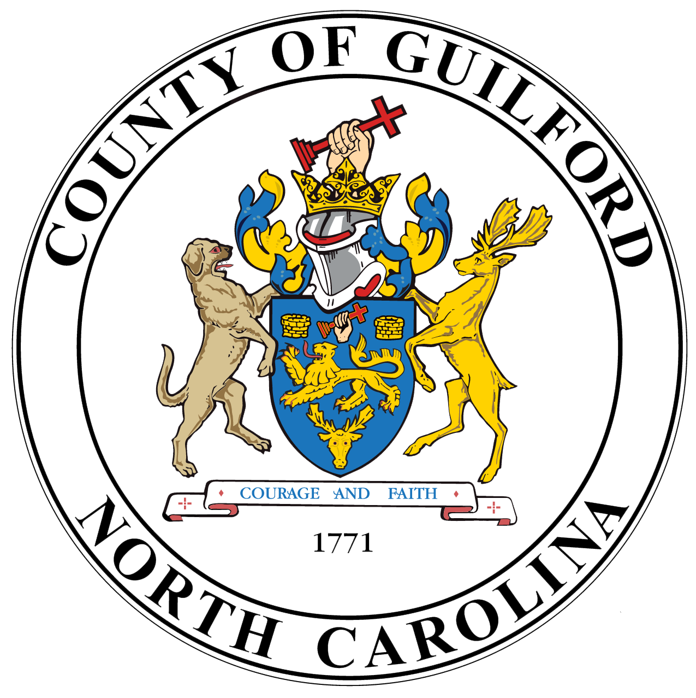
Guilford County Community Based Organization
2026-2027 Outside Nonprofit Application

Date Submitted | Organization Name
Point of Contact | Contact Information  (include phone number and email)
Tax ID Number: | Organization Mailing Address:

Contract Delivery Method (select one option from the following):

☐In – Person | ☐Electronic : Email | ☐Mailed : USPS

Expiration Date for Certification of Liability Insurance Click or tap to enter a date.

Project Description
- Public Purpose Statement:
One sentence that describes how you propose to use the County funds.
- Key Staff:
Please provide key staff that will work on this project or that should be included on communications
- Requested Amount of County Funds

Please identify and describe how your organization’s program aligns with Guilford County’s stategic goals:
Healthy and Thriving People
Lifelong Success
Safe and Resilient Communities
Sustainable and Vibrant Communities
Operational Support and Fiscal Sustainability

How has your organization demostrated success in prior years? (Please include current programs, activites and accomplishments)

Are you currently contracted with Guilford County? If yes, please provide the department and contract purpose)

What is the estimated number of residents served by this program?

Each organization will be required to identify 2-4 performance measures to measure success of the funded program. Please provide your metrics below and a projected completion date.
METRIC | PROJECTED DATE
 | Click or tap to enter a date.
 | Click or tap to enter a date.
 | Click or tap to enter a date.
 | Click or tap to enter a date.
 | Click or tap to enter a date.
 | Click or tap to enter a date.
 | Click or tap to enter a date.

How will you allocate the awarded funds?
(Please list any additional revenue sources used to support this program and show proposed expenses by catergory from County awarded funds)
REVENUE |  | EXPENSE
SOURCES | AMOUNT | USES | AMOUNT
TOTAL |  | TOTAL
NET INCOME

Provide additional information to explain the table above if needed.

How will this program be sustained in future years?

Eligibility Requirements for Nonprofit Agency Applicants to receive Guilford county funding and Attestation of Non-Discrimination
Guilford County shall fulfill the public purposes authorized by law in addressing the needs of all county residents in the lawful provision of services and expenditure of public funds based on NCGS 153a-149(c). Organizations must be a 501(c)(3) federally recognized entity. It must use Guilford County as its primary service place, have an office in Guilford County, and include a majority of Guilford County residents in the service population. In compliance with state and federal laws and regulation, services must be provided to all persons without regard to demographic characteristics. Services which limit admission, access, or benefit based on demographic characteristics will not be considered for funding under this program.

This organization certifies that it adheres to serving all people, regardless of demographic characteristics with the services proposed in this application. Guilford County follows all state and federal laws and regulations, ensuring our policies, procedures, and practices are free from discrimination. This applies to admission, access to, and benefit from, all programs and activities undertaken by Guilford County.

